1. Before Deletion

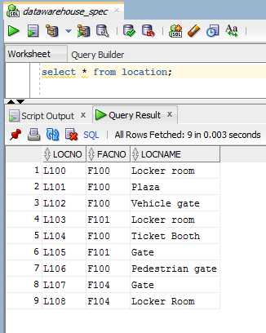

2. Deletion

DELETE FROM Location

WHERE LocNo = 'L108';

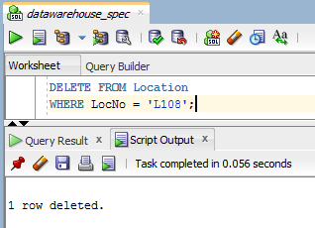

3. After Deletion

